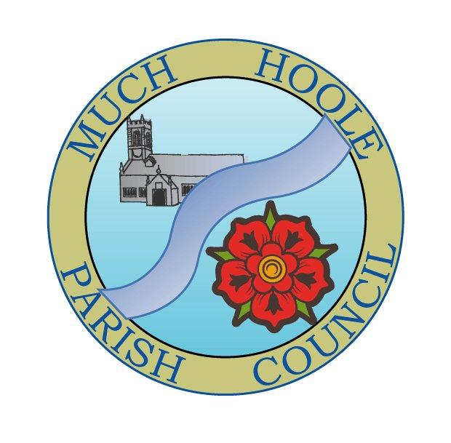 | MUCH HOOLE PARISH COUNCIL  NOTICE OF MEETING
You are summoned to attend a Meeting of Much Hoole Parish Council to be held on Wednesday 14th February 2022, 7.30pm. at The Venue (Hoole Village Memorial Hall) Liverpool Old Road. Members of the Public are invited to attend.

Russ Weaver, Clerk to the Parish Council

AGENDA
1. | Apologies for Absence  To receive apologies for absence  Cllr K Hayes, Cllr T Hewitt
2. | Declaration of Interests and Dispensations  - To receive declarations of interest from Councillors on items on the agenda  - To receive written requests for dispensations for disclosable pecuniary interests (if any)  - To grant any requests for dispensation as appropriate
3. | Minutes of last meeting  To resolve to agree the minutes of 10th January 2022 as a correct record
4. | Public Time  To invite and listen to issues raised by members of the public.
5. | Casual Vacancy  To consider co-option of members of the public who wish to be considered as candidates for the position of Parish Councillor
7. | Finance  To authorise payment of the following:  - To pay the Clerk expenses in the sum of £94,84.- In relation to mileage for December, January and February, printer ink, stamps, magnetic fasteners for notice boards and printer paper),  - To pay A.Taylor for cycle track lease rent arrears in the sum of £360 (agreed lease is £90 per year, payable annually on 11th April) This payment brings rent arrears up to date and the next payment will fall due on 11th April 2022  - To pay Hoole Village Hall meeting room hire invoice for October, November and December 2021 and January 2022 at £10 per hire) Total invoice in sum of £40  - To appoint internal auditor Mr Ian Edwards at a fee of £100  - To approve terms of reference for internal audit (as circulated)
8. | Cycle track update  To consider any issues relating to the cycle track
9. | Reports from / notice of other meetings attended by Councillors or Clerk  To receive reports from meetings attended by Councillors, or notification of meetings due to be attended  LCC have notified a ‘Highways Special’ on Saturday 19th March 2022 9.30am – 2.30pm (including lunch) to improve working relations between Parish Councils and LCC Highways Department
10. | Community led projects  - Progress reports and proposals in relation to ongoing community projects  - To consider a proposal to install Speed Indicator Devices in Much Hoole (see proposal circulated with agenda)  - To discuss other suggestions for community projects  - To discuss proposal to support the organisers of the Village Spring Fair with the cost of providing a climbing wall attraction in the sum of £400
11. | Queens Jubilee  To discuss any issues in relation to the Jubilee celebrations
12. | Training  LALC have circulated training opportunities as follows (All zoom based)  7pm 17th Feb Community Road watch (free)  7pm 21st Feb Whistle stop tour for new Cllrs and Clerks (£35)  7pm 24th Feb Share and learn network for Chairs (free)  7pm 3rd March Planning (£40)
12. | Planning Issues  07/2021/00828/FUL Land Adjacent 26 Park Avenue Much Hoole Lancashire. Erection of 7no. dwellings with associated car parking and landscaping.  07/2021/01275/HOH 28 Liverpool Old Road Much Hoole Preston Lancashire PR4 4RB Single storey rear extension  07/2021/01256/HOH 1 Brooklawns Much Hoole Preston Lancashire PR4 4RF Single storey side extension forming a sunroom
13. | Items for the Next Agenda (for information only)
14. | Date of Next Meeting  The Parish Council to agree the date of the next meeting as 7.30pm 14th March 2022 at the Venue

